00000000000000000000000000000000000000000000000000000000000000000000000000000000000000000000000000000000000000000000000000

JC Rupe

Date: **September 19, 2017**

Version: **1.0.3**



**Project Eden:**

*Outlook Set Regarding - Email Management*

**IT Project Management Office**

Document Revisions

|  |  |  |
| --- | --- | --- |
| Date | Version Number | Document Changes |
| 2016/12/20 | 1.0.0 JC | Document initial creation/completion. |
| 2017/01/03 | 1.0.0 JC | Edited a small amount of the wording. Section 1.1. |
| 2017/01/09 | 1.0.1 JC | Renamed the document to add “Outlook Tracking -“ to its title. |
| 2017/01/12 | 1.0.2 JC | Added references to “Customer Service Reference Guide” to section 1.2 |
| 2017/01/17 | 1.0.2.1 JC | Added document name to footer. |
| 2017/01/18 | 1.0.2.2 JC | Changed document name. Clarified Set Regarding vs. Tracking. |
| 2017/01/19 | 1.0.2.3 JC | Changed the Reply/Forward section. |
| 2017/09/19 | 1.0.3 JC | Updated from EDEN to JIM. |
|  |  |  |
|  |  |  |
|  |  |  |
|  |  |  |
|  |  |  |

Contents

1 Email Management – Set Regarding 3

1.1 About CRM for Outlook 3

1.2 Important Information 3

1.3 Track Email to a Contact – Outlook 4

1.4 Track Email to a Move – Outlook 6

1.5 View Tracked Contact Email – JIM 8

1.6 View Tracked Move Email – JIM 10

1.7 Remove Set Regarding 11

1.7.1 Untrack an Email – Outlook 11

1.7.2 Remove Tracked Email – JIM 12

1.8 Reply/Forward to an Email – JIM 13

# Email Management – Set Regarding

This document explains how to associate Outlook email(s) and email thread(s) into Contact(s) and Move(s) in JIM.

## About CRM for Outlook

CRM for Outlook is very helpful feature that helps to keep track of all your contacts, moves and service activities from the Outlook. When you track an email message, contact, task, or appointment record, a copy of that record is saved as an activity in JIM and synchronized with the Outlook record. You can then view and edit that record in JIM or Outlook.

## Important Information

**General Information**

* CRM for Outlook must be installed on your computer.
  + In the event that you do not have this installed on your system, please contact Technical Services at [techsupport@jkmoving.com](mailto:techsupport@jkmoving.com), so we can assist you in installing the software needed.
* The preferred browser to use is Microsoft Explorer, although, Chrome and Firefox should also work.
* **Selecting a record, not a link in the record:** Try to select a part of the record line that doesn’t contain a link. Remember, text displayed in blue is a link. If you click on the link, it will open that items information page. For example if you select the name of the Contact, the Contact information page in JIM will open. If this happens, you may have to navigate back to the previous page or close the window that opened when you selected the link.
* For assistance with record table view navigation, in JIM, see the steps in section “Navigation of a Record View” section of the “JIM – Customer Service Reference Guide” document.
* For assistance with searching and filtering of records, in JIM, see the steps in section “Search & Filter Record View” section of the “JIM – Customer Service Reference Guide” document.

**Email Set Regarding Tracking Information**

* **Tracked –** Once the **Set Regarding** is set for an email, the email then becomes tracked to either the Contact or the Move, whichever one you set it to.
  + **IMPORTANT –** ONLY use the **Set Regarding** button to track emails, NEVER use the **Track** button.
* Emails Set Regarding (tracked) to the Contact are only seen in JIM at the Contact level, while emails Set Regarding (tracked) to the Move are only seen at the Move level.
* **Email Thread –** Also, called **thread**. An email thread is an email message that includes a running list of all the succeeding replies starting with the original email. The replies are arranged visually near the original message, usually in chronological order from the first reply to the most recent.
  + Once an email is associated with either a Contact or a Move, the other emails in the thread may only be associated with the same Contact or Move. For example: You may not have one email in a thread associated with a Contact and another email in the same thread associated with a Move. -OR- You may not have one email in a thread associated with one Contact and another email in the same thread associated with a different Contact.

## Track Email to a Contact – Outlook

This section shows how to associate an email in an email thread to a Contact. The email will then be visible in JIM at the Contact level.

**Note:** To associate additional emails, even those in the same thread, you need to perform these steps to select the “Set Regarding” button and associate the email to the appropriate Contact or Move.

1. Navigate to Microsoft Outlook.
2. Locate the email to be associated with the Contact.
3. Open the email.
4. Select the “Set Regarding” button up in the tool bar of the open email.
5. If the drop down menu appears select “Contact…” in the menu.

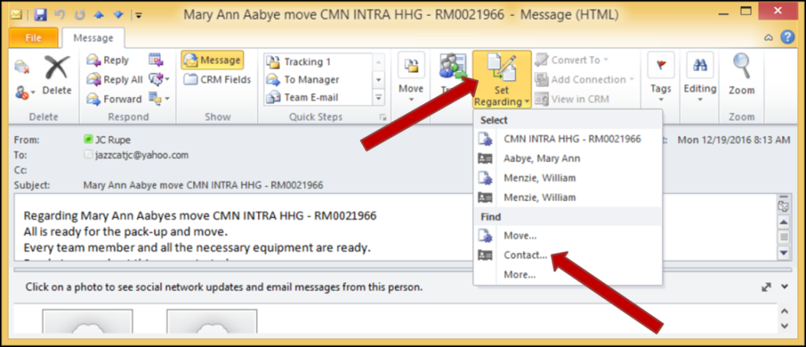

1. The “Look Up Record” window will display.
   1. Set the “Look for” field to Contact.
      1. Select the menu arrow button next to the field.
      2. Locate and select “Contact”
   2. Set the “Look in” field to “Active Contacts”.
      1. Select the menu arrow button next to the field.
      2. Locate and select “Active Contacts”
   3. In the “Search” field enter the Contacts last name.
      1. Select the magnifying glass to conduct the search.
   4. The found records will display in the grid.
   5. Commit the tracking:
      1. Double click on the Contact record to complete the Set Regarding (Tracked).

--OR--

* + 1. Select to highlight the desired Contact record and then select the “Add” button.

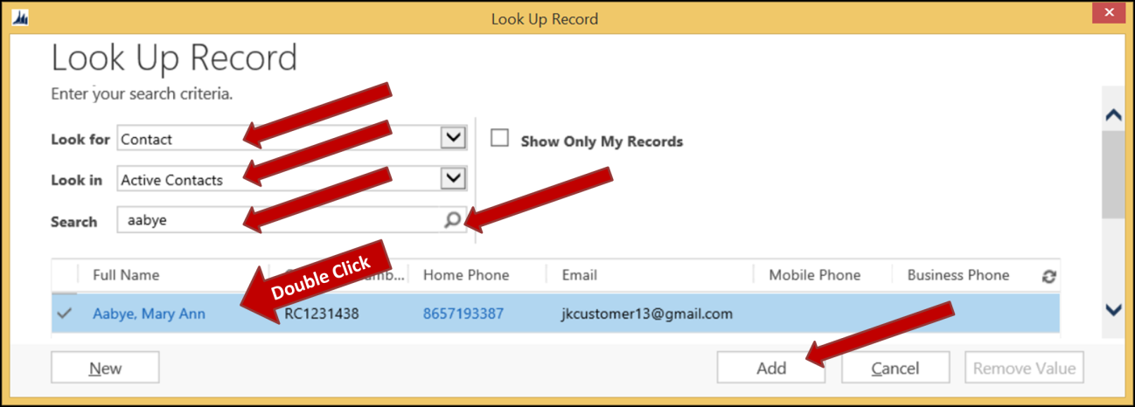

1. The “Look Up Record” window will disappear.
2. If the “Microsoft Dynamics CRM” warning window displays, perform these two steps.
   1. Place a check in the box for “Don’t show this message again”.
   2. Select the “OK” button.
3. The open email window will refresh, showing the “Microsoft Dynamics CRM” panel.
   1. The “Regarding” value is the name of the Contact to which the email is now tracked.
   2. Any related records are listed under “Related records”. (Pictured here it shows the Sender and the Recipient.)

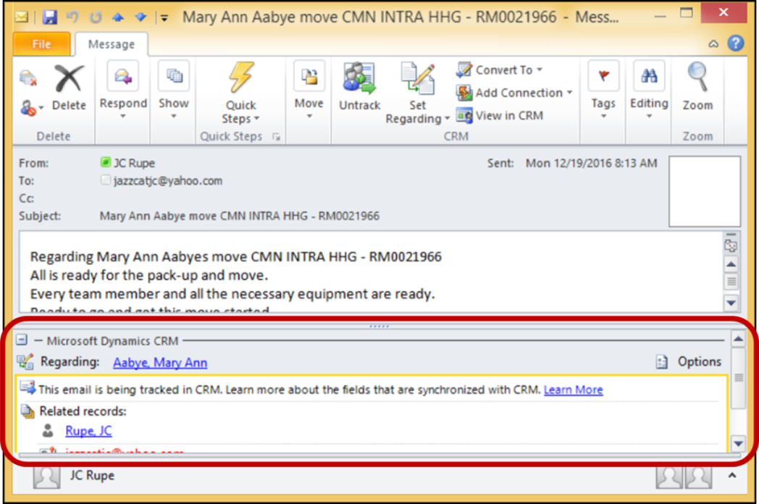

1. Close the email.
2. Microsoft Outlook will refresh.
   1. Notice that the icon for the email, that has been Set Regarding (Tracked), is now changed from an envelope  to two people.
   2. The “Tracking” button now says “Untrack”.

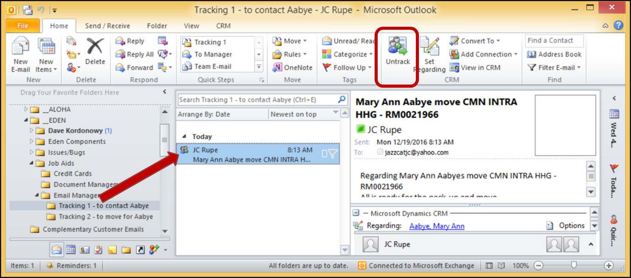

1. **Note:** The emails pictured above are all part of the same email thread, but only the email that was “Set Regarding” (Tracked) is currently being tracked.
2. The tracked email can now be seen through the Contact in JIM.

## Track Email to a Move – Outlook

This section shows how to associate an email thread to a Move. The email will then be visible in JIM at the Move level.

**Note:** To associate additional emails, even those in the same thread, you need to perform these steps to select the “Set Regarding” button and associate the email to the appropriate Contact or Move.

1. Navigate to Microsoft Outlook.
2. Locate the email to be associated with the Contact.
3. Open the email.
4. Select the “Set Regarding” button up in the tool bar of the open email.
5. If the drop down menu appears select “Move…” in the menu.

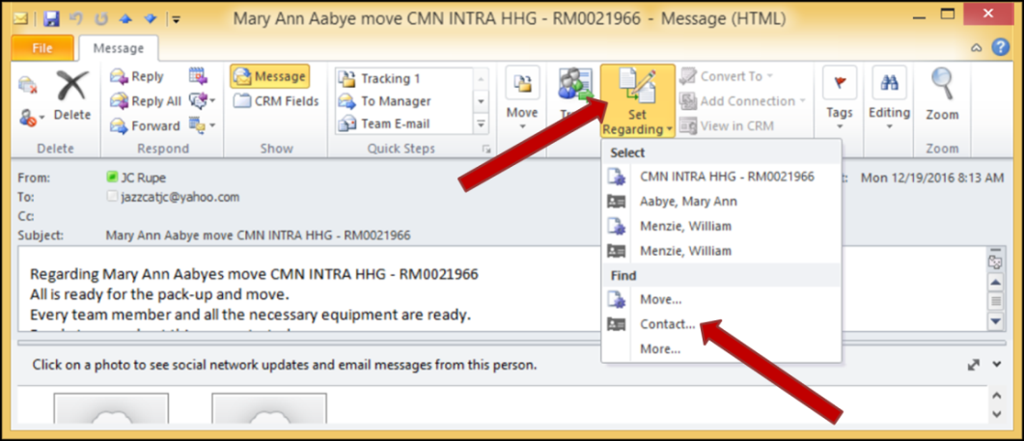

1. The “Look Up Record” window will display.
   1. Set the “Look for” field to “Move”.
   2. Set the “Look in” field to “Move Lookup View”.
   3. In the “Search” field enter the Move number.
      1. **Note:** Searching using the Contact last name is another option.
      2. Select the magnifying glass to conduct the search.
   4. The found record(s) will display in the grid.
   5. Commit the tracking:
      1. Double click on the Move record to complete the Set Regarding (Tracked).

--OR--

* + 1. Select to highlight the desired Move record and then select the “Add” button.

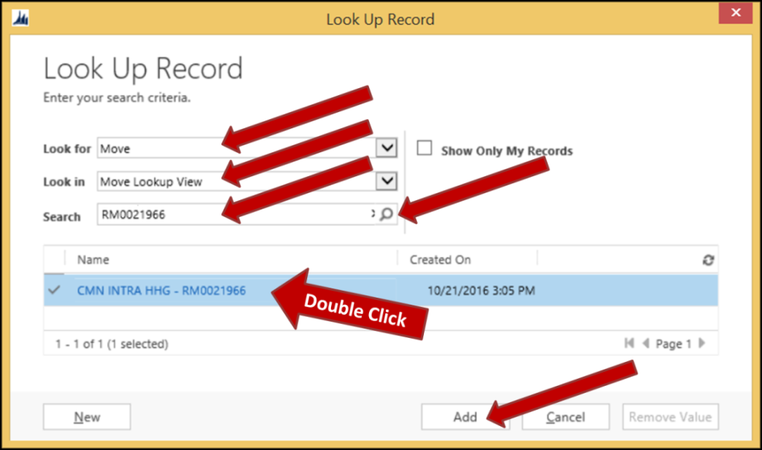

1. The “Look Up Record” window will disappear.
2. The open email window will refresh, showing the “Microsoft Dynamics CRM” panel.
   1. The “Regarding” value is the name of the Move to which the email is now tracked.
   2. Any related records are listed under “Related records”. (Pictured here it shows the Sender and the Recipient.)

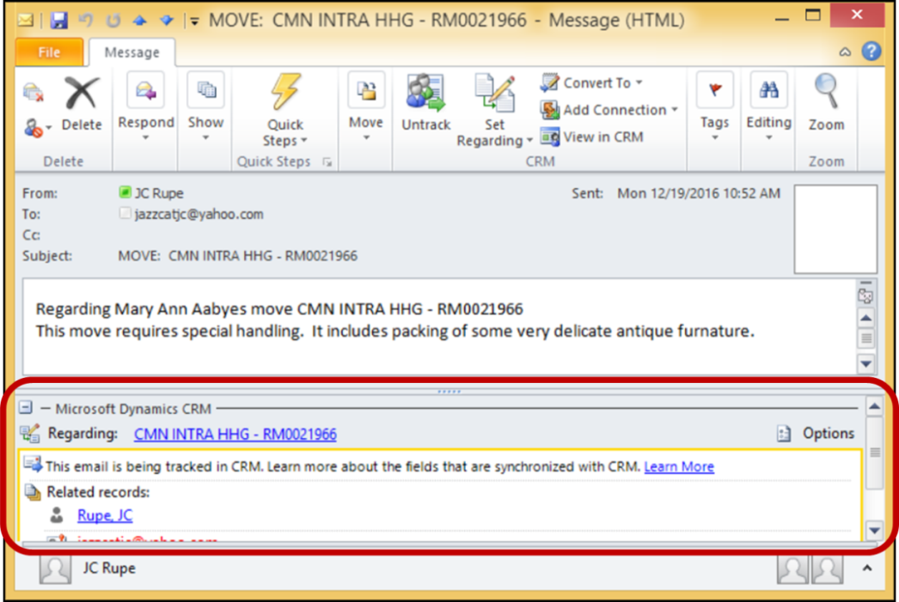

1. Microsoft Outlook will refresh.
   1. **Note:** The emails pictured here happen to all be part of the same email thread. In this example, only the email that was “Set Regarding” (Tracked) is currently being tracked. If more are being tracked, they will also display with the two people icon.
2. The tracked email can now be seen through the Move in JIM.

## View Tracked Contact Email – JIM

This section will show you how to view the emails that are tracked to the Contact.

1. Navigate to the “Contact” page in JIM.
   1. Select the “Main” menu button.
   2. Select the “Service” Work Area.
   3. Locate and select the “Contacts” icon under the “Service” column.
   4. The default Contacts View page will appear.
   5. Enter search criteria to locate the desired Contact/Customer.
   6. Open the Contact record, by clicking on the Contact “Full Name” or by double clicking on the Contact record.
2. The “Contact” page will display.
3. Select the dropdown arrow to the right of the Contacts name, in the top navigation bar.

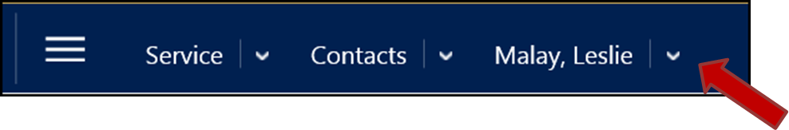

1. Select the “Activities” option, from the dropdown menu.



1. The “Open Activity Associated View” will display.
   1. Set the View to “All Activities”.

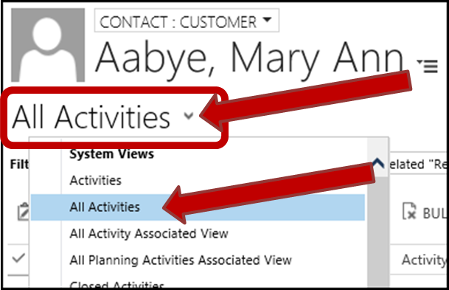

* 1. Set the “Filter on:” value to “All”.
  2. Set the “Include:” value to “Related “Regarding” Records”.

1. Filter the records when necessary.
   1. Turn on the filtering by selecting the Filter button.
   2. Select to filter the “Activity Type” field.
   3. In the filtering dropdown, select to filter for “Email”.
   4. Select the “OK” button.

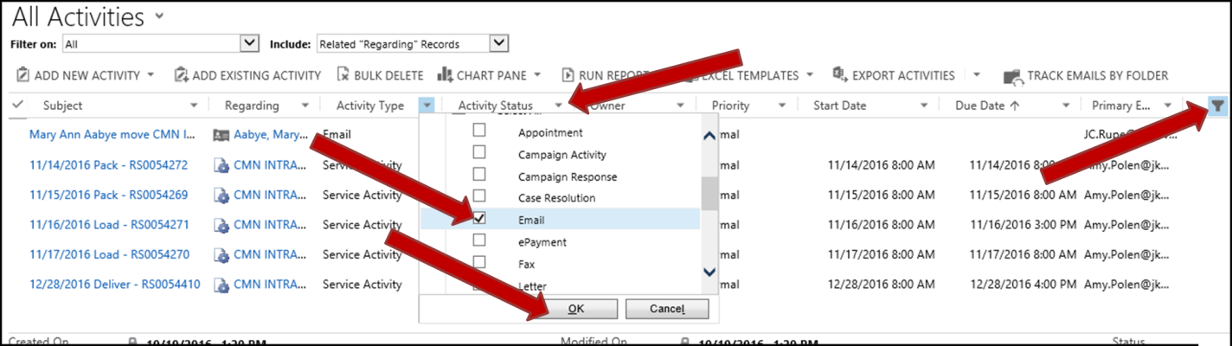

1. The view will refresh and only the Email activities will display in the grid.
   1. Double click on the desired email record.
2. The “Email” page will display with information about the email.
   1. General information, including the email body.
   2. Attachments.
   3. Details about the email.

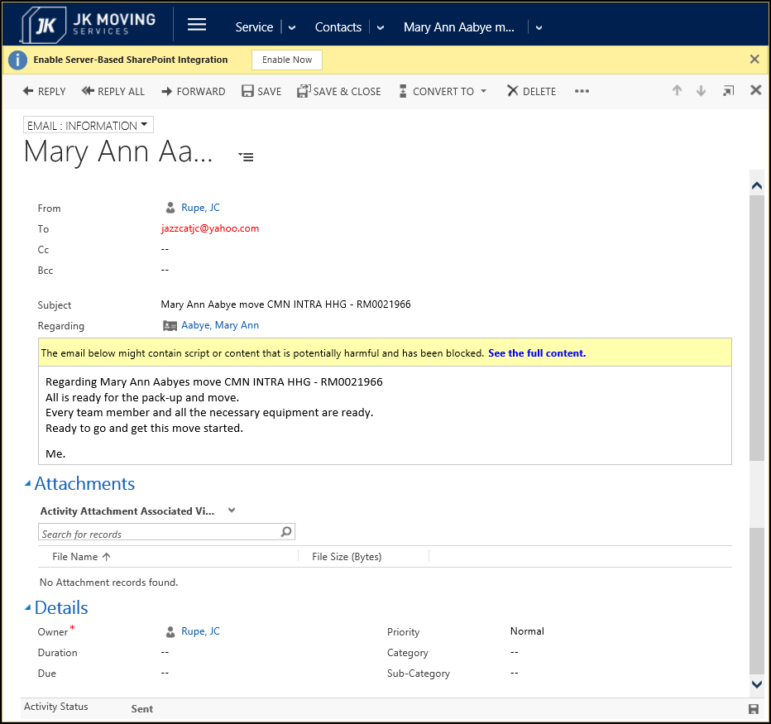

## View Tracked Move Email – JIM

This section will show you how to view, from within JIM, the emails that are tracked to the Move. These steps are quite similar to the steps in the View Tracked Contact Email section.

1. Navigate to the “Move” page in JIM.
   1. Select the “Main” menu button.
   2. Select the “Service” Work Area.
   3. Locate and select the “Moves” icon under the “Extensions” column.
   4. The default Moves View page will appear.
   5. Enter search criteria to locate the desired Move.
   6. Double clicking on the Move record.
2. The “Move” page will display.
3. Select the dropdown arrow to the right of the Move name, in the top navigation bar.



1. Select the “Activities” option, from the dropdown menu.



1. The “Open Activity Associated View” will display.
2. Change the view to “All Activities”.
3. Turn on the Filtering.
4. Filter for only Email “Activity Type”.

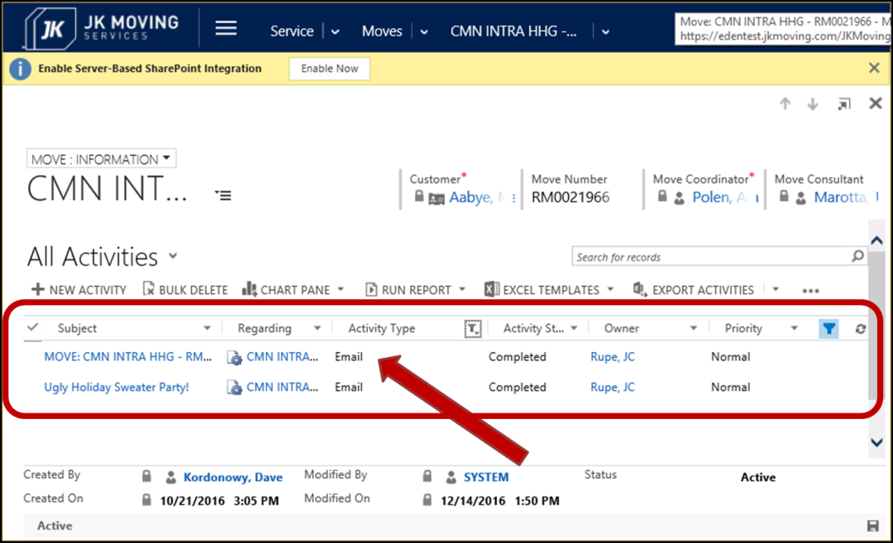

1. The view will refresh and only the Email activities will display in the grid.
   1. Double click on the desired email record.
2. The “Email” page will display with information about the email.
   1. General information, including the email body.
   2. Attachments.
   3. Details about the email.

## Remove Set Regarding

Once the Set Regarding tracking is removed from the email it will no longer be seen in JIM.

* **NOTE:** Once an email is tracked to a Contact or Move in JIM, the emails information is stored in JIM.
  + Deleting a tracked email from Outlook does NOT remove it from JIM.
  + Deleting a tracked email from JIM does NOT remove it from Outlook.

### Untrack an Email – Outlook

This section will show how to remove an email from being Set Regarding tracked. Once the Set Regarding tracking is removed from the email it will no longer be seen in JIM.

1. Navigate to Microsoft Outlook.
2. Select and open the tracked email that is to be removed from tracking.
3. Select the “Untrack” button in the upper menu bar.
   1. **Note:** This will undo the Set Regarding tracking.



1. A message window will display asking if you are sure you want to take this action.
   1. Select the “Yes” button.

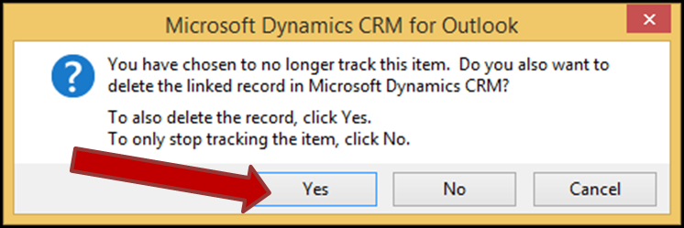

1. If the “Microsoft Dynamics CRM” warning window displays, perform these two steps.
   1. Place a check in the box for “Don’t show this message again”.
   2. Select the “OK” button.
2. Microsoft Outlook will refresh.

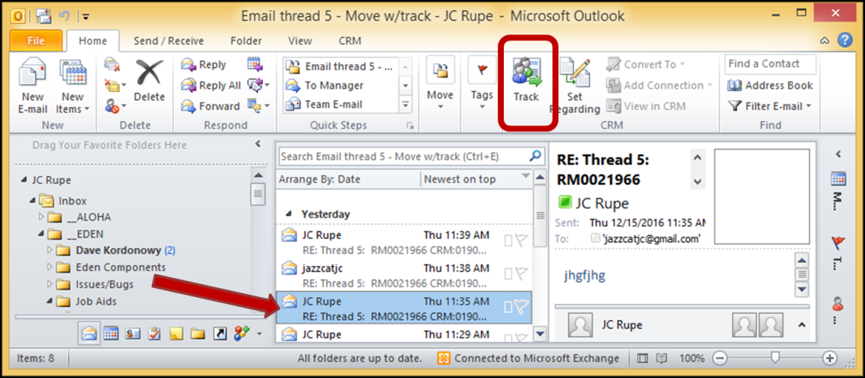

* 1. Notice that the icon for the email, removed from tracking, is now changed back to an envelope.
  2. The “Tracking” button now says “Untrack”.

1. The email is no longer tracked in Outlook.
2. The email is no longer in JIM.

### Remove Tracked Email – JIM

This section will show how to remove an email from being tracked. Once removed from tracking the email will no longer be seen from JIM in either the Contact or Move views.

Best practice is to not use this method to remove an email from JIM. The preferred method is to remove the tracking from Outlook. See Remove Tracking from an Email – Outlook.

1. Navigate to the desired email.
   1. View Tracked Contact Email – JIM

--OR--

* 1. View Tracked Move Email – JIM

1. The “Email” page will be displayed with information about the email.
2. Select the “Delete” button on the emails menu bar near the top of the window. 
3. A confirmation box will display.
   1. Select the “Delete” button.

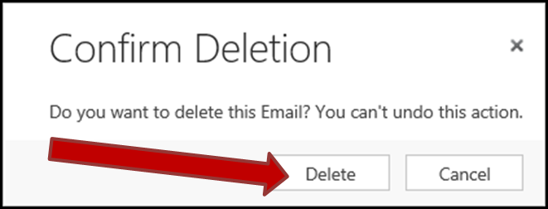

1. The email is now deleted from JIM.
2. **Note:** In Outlook, where the email was originally “Set Regarding”, the email still shows that it is being tracked.

## Reply/Forward to an Email – JIM

This section will show you how to reply to or forward an email from within JIM. Replies and forwarded email, from within JIM, are automatically tracked.

1. Navigate to the “Email” page in JIM.
   1. See either section View Tracked Contact Email or section View Tracked Move Email in this document.
2. The “Email” page will be displayed.
3. Select to Reply or Forward, compose message and send email.
   1. See the steps in section “Reply or Forward Email” of the “JIM - Customer Service Reference Guide” document.
4. The Reply/Forward email is now sent out.
   1. **Note:** Since the original email was Set Regarding tracked, the Reply/Forward email is also tracked.
   2. The tracked email sent from JIM is stored in JIM.

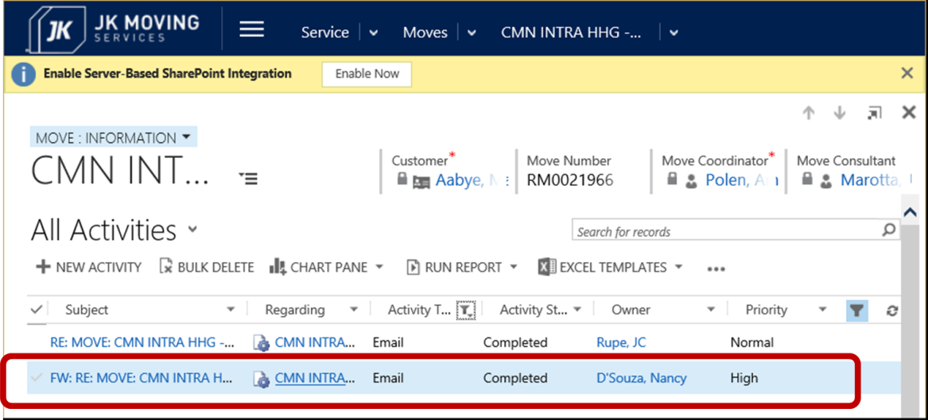

* 1. You will find the tracked email sent from JIM in your Outlook email “Sent” folder and it will already be set as Set Regarding tracked to what the original email is tracked (either the Contact or Move).

